Third Sunday of Lent  Reading I: Genesis 22:1-2, 9a, 10-13, 15-18  Responsorial Psalm: 116:10, 15, 16-17, 18-19  Reading II: Romans 8:31b-34  Gospel: Mark 9:2-10  https://bible.usccb.org/bible/readings/030324-YearB.cfm | 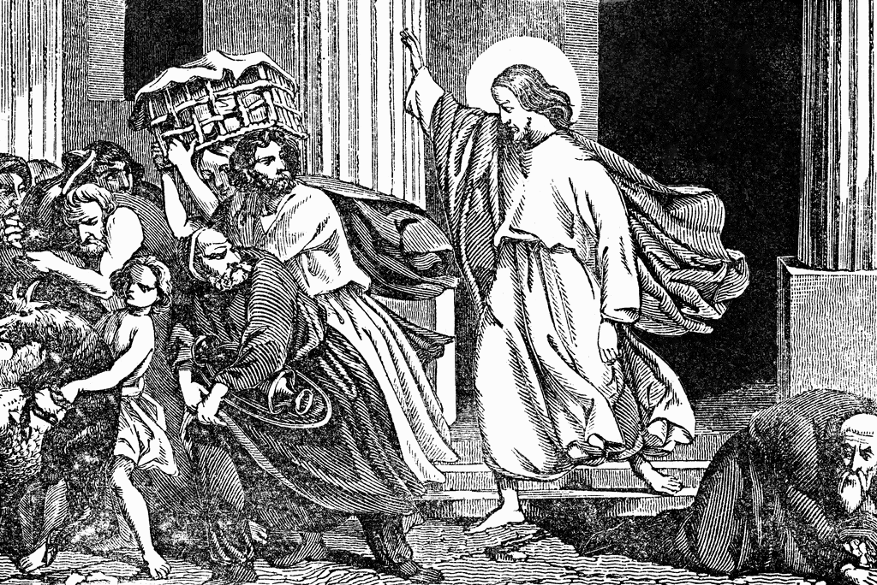

Fr. John Kavanaugh, SJ, wrote concerning the commandments: "each is an expression of the truth God has made in us…For the duty imposed on us, … is the duty to be true to what we are—limited but loved creatures.” (Homily for the Third Sunday of Lent)
The commandments were the external sign of maintaining the covenant relationship with God. To be part of this life-giving relationship, one had duties to God and one’s neighbor. This promoted a common set of norms for the people of Israel. Just as God had responsibilities as a partner in the covenant, Israel had responsibilities to God in honoring and expressing commitment to God by honoring God and one another.
This ethic was unique as other cultures did not understand God to be interested in how one treats those around you. There were civil codes for good order in society, but the understanding that God cared about how one treated others was unique to Judaism.
As stated above, these commands are expressions of the dignity of each person. Injuring or destroying those who gave you life, depriving someone of life, of their life partner, their reputation, or their possessions, are a repudiation of the dignity and life that God gave them.
The reading of the commandments during Lent invites us to reflect on the cleanliness of our hearts. As Christians, we are temples of the Holy Spirit through Christian Initiation. Christians are called to renew their relationship with God during Lent and to purify one’s heart and relationship with God so that we may have a heart that is welcoming to God.
For a proper understanding of the text, a cultural note is needed. Women and children were both understood to be possessions of their fathers or husbands. The proper dignity of children and women only developed as the understanding of God’s revelation developed over time. The Church does not understand these texts literally but as part of the developing understanding of God’s revelation. “In times past, God spoke in partial and various ways to our ancestors through the prophets; in these last days, he spoke to us through a son, whom he made heir of all things and through whom he created the universe.” Hebrews 1: 1-2
The reading from the first chapter of First Corinthians raises the issues Paul's contemporaries gave for not accepting Jesus. Jesus did not meet their expectations. For Jews, the Messiah would be the conquering King who would restore Israel to preeminence in the world. Jesus died on a cross. This was a horrendous death, and those who hung on a tree were cursed. (Deut 21:23) For the Jewish culture, this could not logically be the Messiah. He was defeated by the evil culture.
The Greek culture looked for Wisdom. They looked for logical reasoning that would show opponents were untrue. Jesus invited people to faith that was beyond reasoning. This did not meet their expectations.
For the Christian, the resurrection showed that Jesus was ultimately vindicated. He did not seek a physical kingdom nor to defeat enemies with logical arguments. He conquered evil by love and obedience. He defeated death in the resurrection. This victory was beyond any other victory that the different cultures sought.
Thus far this year, our Gospel passages have been from Mark, who was writing in the late 60s, 30+ years after the death of Jesus. Today and on the next two Sundays, the Gospel passages will be from John, who wrote near the end of the first century. John’s audience has a different life experience from Mark’s audience. For John's audience, the Temple has been destroyed, and Christianity is becoming a distinct religion.
John places the passage about the cleansing of the Temple near the beginning of his Gospel. The Temple was the place of God’s presence. One went to the Temple to seek God. Now, the Temple no longer exists. Jesus has shown authority over the Temple. He does not refer to the building when he speaks about raising the Temple in three days. He is describing his resurrection. He is the divine presence in the new order of things. As the Risen Lord, Jesus is present in the Church and the source of life. Where two or three are gathered, Jesus is present. There is no need to go to a building. One only needs to gather as Church to experience God's presence.
Themes
Commandments Temple
Paschal Mystery God’s presence in

Reflection Questions
What principles guide your understanding of right and wrong?
What expectations do you have of God? How are you challenged by the words and deeds of Jesus?
Where do you find God's presence in your life?
How do you manifest God’s presence to others?

Prayer suggestions
For the Church: that we may grow in our awareness of our dignity as temples of the Holy Spirit
For a deeper appreciation of the commandments: that we may allow the wisdom and vision of the commandments given to Moses to form our conscience and guide our decisions
For a spirit of integrity: that we recognize ourselves as servants of God, honoring God's name through our words and deeds and never attempting to use God for our benefit
For a cleansing of the Temple of our hearts: that God will free us from all that enslaves us and help us to offer our self-sacrificing service to God and others
© Joseph Milner, 2024

